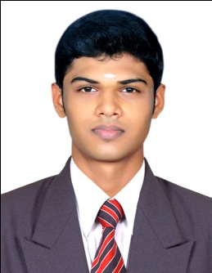
JIBIN.G

Email: jibi.gangadhar02@gmail.com
Mobile: 9112185854/ 9809302914
Address:
2/10 Santosh Apt,
Lucas Compound,SVP Road,
Ambernath West.
Pin :421501

Career Objective:

To obtain a creative and challenging position in the field of logistics that gives me an opportunity for self improvement and leadership while contributing to the symbolic growth of the organization with my technical, innovative and logical skills.

Academic Qualification | Institute /University | Year of passing | CGPA
MBA in Logistics and Shipping | Bharathiyar University | 2015 | 64%
Graduation (Bsc. Mathematics) | Calicut University | 2013 | 65%
HSE | G.B.H.S.S, Nemmara | 2010 | 70%
SSLC | M.N.K.M.H.S.S, Chittilamcherry | 2008 | 79%
Academic Details:

Industrial Exposure:
- Completed 3 months Industrial Internship Programme at SARR FREIGHTS CORPORATION at Mumbai. While the programme, I had experienced:-
- Documentation
- Operations

- Done a project on “A STUDY ON SUPPLY CHAIN MANAGEMENT” at Mardec R K Latex Pvt Ltd.

Computer Knowledge:
- Operating System: Windows.
- Utilities: MS Word, Excel, PowerPoint.
- Other Packages: Computerized Accounting.
Extra Curricular Activities and Achievements:
- Was active in NCC and have its certificate (NCC ‘A’ certificate).
- Was an active participant in N.S.S programs in H.S.E & College.
- Volunteered many association programs at college.
Personal Profile:
Name : Jibin G
Sex : Male
Father’s Name : Gangadharan.K
Date of Birth : 22/11/1992
Age : 23
Marital Status : Single
Religion : Hindu
Blood group : B^{-ve}
Hobbies : Reading, Travelling, Gardening.
Permanent Address : Sasthamandiram (H), Nochukulam,
Chittilamcherry (Po), Palakkad (dist),
Kerala. Pin: 678 704
Languages known:
Read : English, Hindi, Malayalam
Write : English, Hindi, Malayalam
Speak : English, Hindi, Malayalam, Tamil

DECLARATION
I hereby declare that the information given above is true and correct to the best of my knowledge and belief.

Place: Ambarnath (W) JIBIN. G
Date:

